**Q. Program for BCD addition.**

**Without User Input:**

**CODE:**

DISPLAY MACRO MSG

LEA DX,MSG

MOV AH,09H

INT 21H

ENDM

DATA SEGMENT

NO1 DB 31H

NO2 DB 54H

RES DB ?

M1 DB 10, 13, "RESULT IS: $"

DATA ENDS

CODE SEGMENT

ASSUME CS: CODE, DS: DATA

START:

MOV AX, DATA

MOV DS, AX

DISPLAY M1

MOV AL, NO1

MOV BL, NO2

ADD AL, BL

DAA

MOV RES, AL

MOV AH, 00H

ADC AH, 00H

ADD AH, 30H

MOV DL, AH

MOV AH, 02H

INT 21H

MOV AL, RES

AND AL, 0F0H

MOV CL, 04H

ROR AL, CL

ADD AL, 30H

MOV DL, AL

MOV AH, 02H

INT 21H

MOV AL, RES

AND AL, 0FH

ADD AL, 30H

MOV DL, AL

MOV AH, 02H

INT 21H

CODE ENDS

END START

**OUTPUT:**

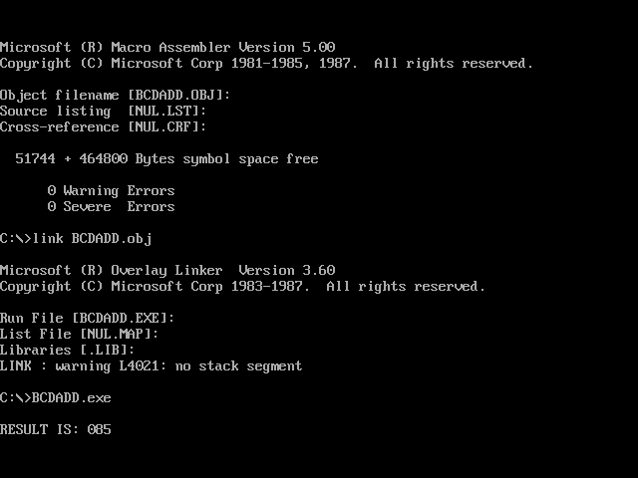

**With User Input:**

**CODE:**

PRINT MACRO MSG

LEA DX,MSG

MOV AH,09H

INT 21H

ENDM

DATA SEGMENT

NO1 DB ?

NO2 DB ?

M2 DB 10, 13, "ENTER N01: $"

M3 DB 10, 13, "ENTER NO2: $"

RES DB ?

M1 DB 10, 13, "RESULT IS: $"

DATA ENDS

CODE SEGMENT

ASSUME CS: CODE, DS: DATA

START:

MOV AX, DATA

MOV DS, AX

PRINT M2

CALL INPUT

MOV CL, 04H

ROR AL, CL

MOV CH, AL

CALL INPUT

ADD AL, CH

MOV NO1, AL

PRINT M3

CALL INPUT

MOV CL, 04H

ROR AL, CL

MOV CH, AL

CALL INPUT

ADD AL, CH

MOV NO2, AL

PRINT M1

MOV AL, NO1

MOV BL, NO2

ADD AL, BL

DAA

MOV RES, AL

MOV AH, 00H

ADC AH, 00H

ADD AH, 30H

MOV DL, AH

MOV AH, 02H

INT 21H

MOV AL, RES

AND AL, 0F0H

MOV CL, 04H

ROR AL, CL

ADD AL, 30H

MOV DL, AL

MOV AH, 02H

INT 21H

MOV AL, RES

AND AL, 0FH

ADD AL, 30H

MOV DL, AL

MOV AH, 02H

INT 21H

INPUT PROC NEAR

MOV AH, 01H

INT 21H

SUB AL, 30H

RET

INPUT ENDP

MOV AH, 4CH

INT 21H

CODE ENDS

END START

**OUTPUT:**

